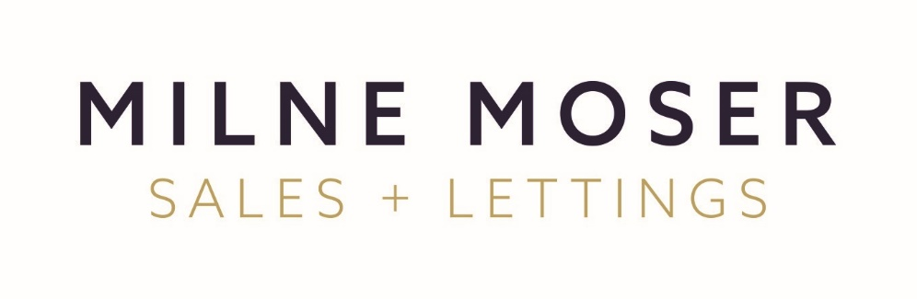
Data Subject Access Request Form

Please complete this form if you wish to request access to your personal data. You do not have to use this form, but it will help us to deal with your request as quickly and effectively as possible if you do.
You can also use this form if you are requesting access to personal data on behalf of someone else. In that case, we will need you to confirm you have that person’s authority to ask for access to their data.
If you have any questions about this form or your request, please contact Miss Justine Rebecca Allen to discuss it further.
- About you
Please provide the following information. If you have an account number or other reference number, please provide it.
Full name | [Details to be inserted here]
Address | [Details to be inserted here]
Contact Email Address | [Details to be inserted here]
Contact Telephone | [Details to be inserted here]
Our Reference | [Details to be inserted here]
Address of Property for sale/to let | [Details to be inserted here]

For security reasons, we cannot respond to a request unless we have confirmed your identity. Please provide:
- a certified copy photo driving licence or passport, and
- a utility bill or other proof of address which was dated no more than 3 months’ ago.

- Whose personal data are you requesting?
Please provide the following information. If you are making this request on behalf of someone else, we will need this information before we can supply you with the data you are asking for.
Are you requesting access to your own personal data? | ☐ Yes, please go to section 3 below.  ☐ No, please complete the rest of this section of the form.

  - If you are not requesting access to your own personal data, please provide the following information about the person on whose behalf you are making this request:
Full name | [Details to be inserted here]
Address | [Details to be inserted here]
Contact details | [Details to be inserted here]
Our Reference | [Details to be inserted here]
Age (if under 16) | [Details to be inserted here]

We cannot respond to your request until we also receive satisfactory confirmation of the identity of the person on whose behalf you are making this request. Please provide:
- a certified copy photo driving licence or passport, and
- a utility bill or other proof of address which was dated no more than 3 months’ ago.
  - Please provide a copy of your legal authority to make this request. This might be a signed letter of authority from the person on whose behalf you are making this request, a power of attorney, or confirmation that you are their legal representative.

- What data are you requesting?
Your rights to request access to personal data and other information are set out in our Privacy policy, available on our website. Please describe what personal data and other information you are requesting, in particular if you are asking for specific documents or information.
Description of the personal data and information requested including details of any specific documents or information you are asking for (where relevant) | [Details to be inserted here]

Please give as much detail as possible about where the data might be located and any other relevant information. You do not have to provide this information, but doing so will help us to deal with your request as quickly and effectively as possible.

Location of data, e.g. any particular departments or parts of the organisation you have dealt with (if known) | [Details to be inserted here]
Relevant time periods, e.g. when we are likely to have obtained your data (if known) | [Details to be inserted here]
Dates of any particular correspondence, meetings or telephone calls (if known) | [Details to be inserted here]
The name(s) of people you have dealt with within our organisation (if known) | [Details to be inserted here]
Any other relevant information you can think of that might help us respond to your request | [Details to be inserted here]

- Signature
Please check the information you have provided and sign below.
Signed
Date

Please send this form and the documents we have asked you to provide to:
Miss Justine R. Allen
Milne Moser Property Limited
100 Highgate, Kendal, Cumbria, LA9 4HE
Email: justine@milnemoser.co.uk
If you are making this request by email, we will provide the information to you in an electronic format unless you ask us not to. If you wish to receive your information in a different format, e.g. hard copy please let us know in the box below.
[Details to be inserted here]

